Software Requirements Specification

for

Library Management System
Version 1.5 approved
Prepared by :
Floricescu Cristina-Ștefania
Bejoiu Roxana-Georgiana
Căpățînă Ecaterina-Mihaela

Organization:
Faculty of Automation,Computers and Electronics
Date Created :23.02.2026
Table of Contents
Table of Contents ii
Revision History ii
1. Introduction 1
1.1 Purpose 1
1.2 Document Conventions 1
1.3 Intended Audience and Reading Suggestions 1
1.4 Product Scope 1
1.5 References 1
2. Overall Description 2
2.1 Product Perspective 2
2.2 Product Functions 2
2.3 User Classes and Characteristics 2
2.4 Operating Environment 2
2.5 Design and Implementation Constraints 2
2.6 User Documentation 2
2.7 Assumptions and Dependencies 3
3. External Interface Requirements 3
3.1 User Interfaces 3
3.2 Hardware Interfaces 3
3.3 Software Interfaces 3
3.4 Communications Interfaces 3
4. System Features 4
4.1 System Feature 1 4
4.2 System Feature 2 (and so on) 4
5. Other Nonfunctional Requirements 4
5.1 Performance Requirements 4
5.2 Safety Requirements 5
5.3 Security Requirements 5
5.4 Software Quality Attributes 5
5.5 Business Rules 5
6. Other Requirements 5
Appendix A: Glossary 5
Appendix B: Analysis Models 5
Appendix C: To Be Determined List 6

Revision History
Name | Date | Reason For Changes | Version
Căpățînă Ecaterina-Mihaela | 24.02.2026 | Completed.  1.Introduction  2.Overall Description | 1.0
Bejoiu Roxana Georgiana | 25.02.2026 | Completed  3.External Interface Requirements  5.Other NonFunctional Requirements | 1.1
Floricescu Cristina-Stefania | 26.02.2026 | Completed  4.System Features  6.Other Requirements | 1.2
Bejoiu Roxana-Georgiana | 01.02.2026 | Modified  4.System Features: 4.5 User Management  2.3 User classes and Characteristics | 1.3
Floricescu Cristina-Stefania | 03.03.2026 | Modified  5.4 Software Quality Attributes  3.3 Software Interfaces | 1.4
Căpățînă Ecaterina-Mihaela | 04.03.2026 | Modified  3.1 User Interfaces  2.7 Assumptions and Dependencies | 1.5

Introduction

Purpose

The aim of the project is to develop a software system designed to automate the management of a library’s activities and create an efficient circulation system between users and the library.

The system will handle the collection and organization of data related to available books, manage client information, and generate relevant reports. It will also provide users with access to information through a web portal, allow system queries, and support document workflow management for processing reservations efficiently.

Document Conventions
The entire document should be clearly structured and justified.
Convention for Main Title:
- Font Face: Times New Roman
- Font Style: Bold
- Font Size: 32
Convention for Subtitles:
- Font Face: Times New Roman
- Font Style: Bold
- Font Size: 14
Convention for Body Text:
- Font Face: Times New Roman
- Font Size: 12

1.3 Intended Audience and Reading Suggestions
This document is primarily intended for library users. This application approach ensures that requirements correctly capture their needs and they can gain a detailed insight into its technical and operational aspects.
Readers are advised to to read the document sequentially, starting with the introductory sections to understand the document’s purpose, conventions, and structure before moving on to the system description and detailed tehnical requirements.

1.4 Product Scope
The Library Management System represents the modernization of a traditional manual library system into a web-based application. It enables users to access information regarding their accounts, check book availability, and view borrowing limits online.
The system is designed to support both librarians and library members by providing a complete interface for managing library operations. It facilitates book management activities such as adding new books, updating records, monitoring loans, and tracking borrowed items. The system can be implemented in both existing and newly established libraries, offering flexibility and scalability. It is particularly beneficial for educational institutions, where content updates and modifications can be performed efficiently according to evolving requirements.
The architecture of the system allows for easy expansion, enabling new features to be integrated whenever necessary. Its modular design ensures flexibility, maintainability, and reusability across different operational scenarios.

1.5 References
www.aman.ro
https://www.slideshare.net
https://www.scribd.com
https://www.geeksforgeeks.org/advance-java/jsp-login-and-logout-form/
https://www.geeksforgeeks.org/springboot/introduction-to-spring-boot/
https://app.diagrams.net/

Overall Description

Product Perspective
The Library Management System is a software system developed to replace the existing manual library workflows and optimize the management of user-related processes within a library.

Product Functions
This system includes the following functions that complete the web app:

Member functionalities:

- Viewing the books available in the library
- Owning a personal library account
- Viewing the list of borrowed books
- Submitting requests for a new book
- Searching for a specific book
- Receiving notifications
- Submit reviews and ratings for books
Librarian functionalities:
- Issuing a book to a member
- Viewing the books available in the library
- Receiving returned books from members
- Extending the period for borrowing a book
- Editing the information of existing books
- Checking reports of the existing books
- Checking reports of the issued books
- Accessing all member accounts

Administrator functionalities:
- Managing user access and permission.
- Resolving technical issues.
- Sending informative emails to registered users.
- User and catalog management

User Classes and Characteristics
The system delivers different services depending on the user role, clearly distinguishing between the Administrator, the Librarian, and the Member.
The Librarian manages the operational activities within the library. This role includes issuing and receiving books, updating and maintaining book records, and managing the various library branches. Additionally, the Librarian is responsible for monitoring loan reports and overseeing the “unwanted clients” list, which includes members who fail to return borrowed items on time.
The Member, on the other hand, represents a registered user who accesses library services through the online portal. Members can manage their personal accounts, check both current and past borrowed books, and submit requests or reservations for specific titles.
The Administrator has an essential role in ensuring the optimal and secure operation of the platform. They manage user access and permissions, meticulously controlling who can access specific information and functionalities. By resolving technical issues and providing support to users.
Although, all roles can browse book categories and check availability, their permissions differ significantly. Members have limited, self-service access focused on their own accounts and activities, the Librarian manages library operations, while Administrator maintains full authority over technical control and system-wide management.

Operating Environment
The Library Management System shall operate in the following environment:
- modern web browser including: Google Chrome(version 100 or later), Microsoft Edge (version 100 or later)
- Any person who will use this application must have the following: Internet Access, a device running Windows 10 or Windows 11
- The system will be hosted on a web server responsible for processing application requests and managing the database. The application will be accessible through the internet using a server IP address or domain via HTTP/HTTPS protocols.

Design and Implementation Constraints
The system’s development relies on a three-tier distributed architecture (database, application, and web server) and the implementation of a secure web interface. Technical requirements include a mandatory authentication module to ensure differentiated access and the use of a DBMS(Database Management System) capable of managing large volumes of data. The implementation must also include mechanisms for data recovery at specific points in time.
Additionally, the database should be designed to allow the storage and automatic correlation of information about readers, branches, and book records, including the management of an delinquent borrowers table based on overdue returns.

User Documentation
This Word document serves as the Software Requirements Specification (SRS) for the project and will take the place of the user guide and other supporting documentation.

Assumptions and Dependencies
The success of the project will rely on the premise that the software is intuitive and free of programming errors, providing users with an easy experience and fast transaction processing. It is assumed that the system will operate 24/7, with scalable storage capacity to host the centralized database containing information about users, books, and libraries.
A major dependency will be the accuracy of the data entered, making it essential for administrators to have a correct understanding of the system to generate accurate reports and manage online accounts.
Additionally, the application’s operation will depend directly on a stable internet connection and the use of valid credentials (username and password) by members accessing the system from any computer.

Assumptions:
- Error-free coding: It is assumed that the development process will produce code without critical errors to ensure fast and secure transactions.
- Hardware availability: The hosting server is assumed to have scalable storage capacity and support 24/7 system operation.
- Accessibility: End users are assumed to have computers with up-to-date web browsers and stable internet connections.

Dependencies:
- Data accuracy: The system’s success will depend directly on the correctness of information manually entered by administrators regarding books and users.
- Administrator training: The project will rely on administrators’ proper understanding of system functionalities to generate valid reports.
- Credential security: The operation of online accounts depends on registered members using correct usernames and passwords.

External Interface Requirements

User Interfaces
The software will provide graphical user interfaces (GUIs) for all. Once registered, they can log in by entering their username/email and password. If either field is incorrect, a clear error message will appear.
Login Interface: Users who are not yet registered can enter their details to create an account. Once registered, they can log in by entering their username and password. If either field is incorrect, a clear error message will appear.
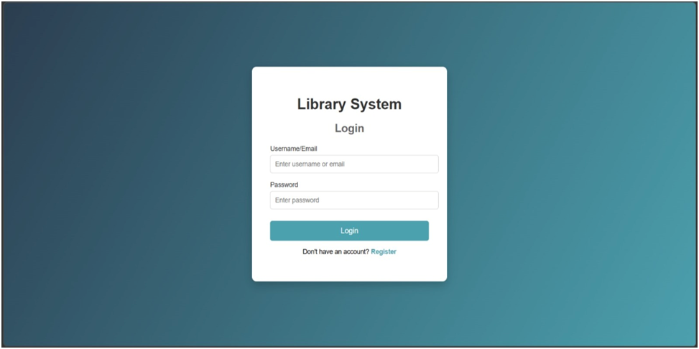

Search Interface: Members or librarians can search for books by title, type, or other criteria, allowing quick access to required resources.
Categories View: This interface displays the categories of books available in the library and allows librarians to add, edit, or remove categories from the list.
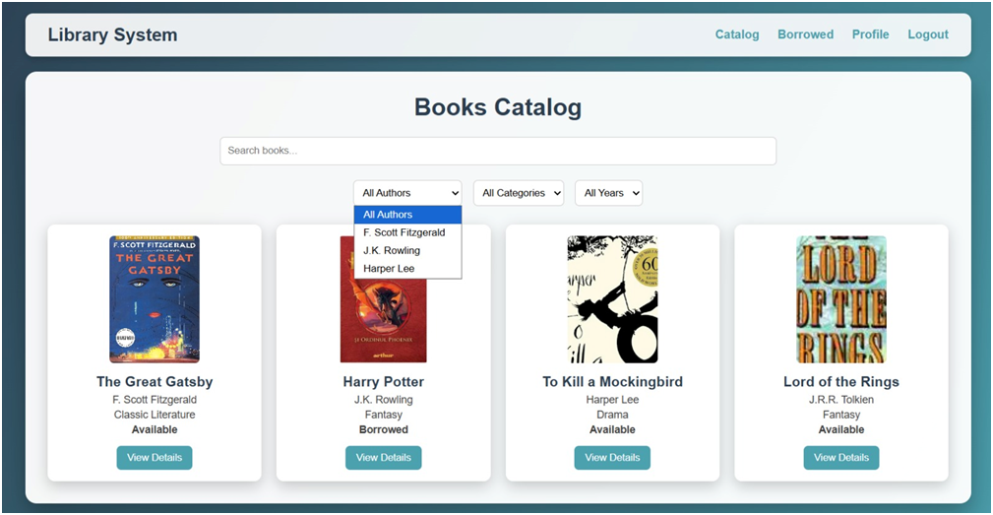
Book Details Page / Reviews and Ratings: Each book in the catalog has a dedicated details page where members can view existing reviews and ratings. Members are able to add new reviews and provide a numeric rating from 1 to 5 stars. They can also delete their own reviews at any time. Submitted reviews and ratings are displayed immediately to all users, allowing everyone to see the latest feedback. Additionally, users can filter or sort reviews, for example by newest first or by highest rating, to easily find relevant opinions.

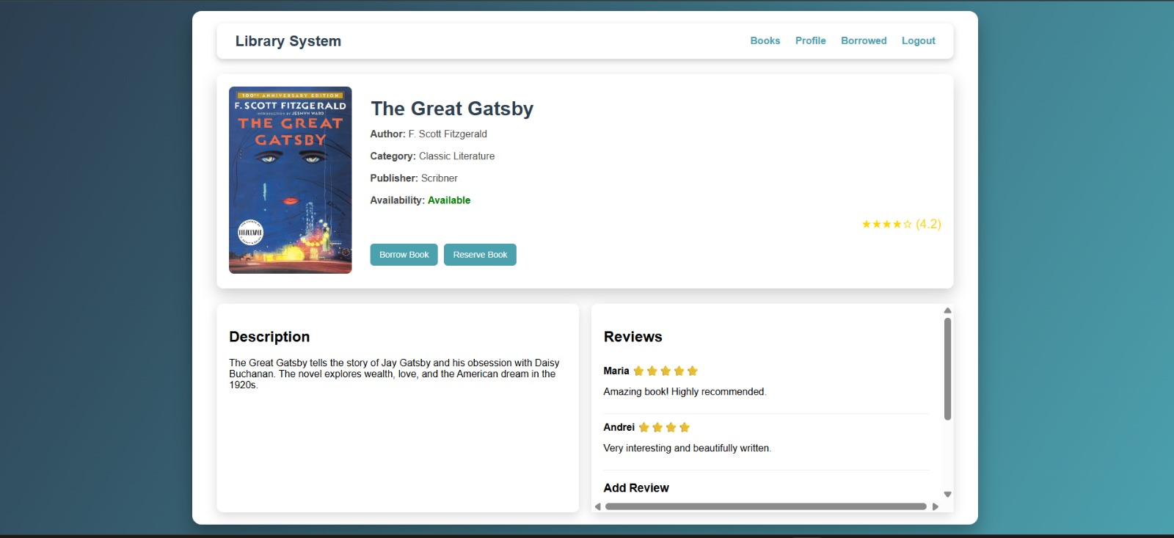
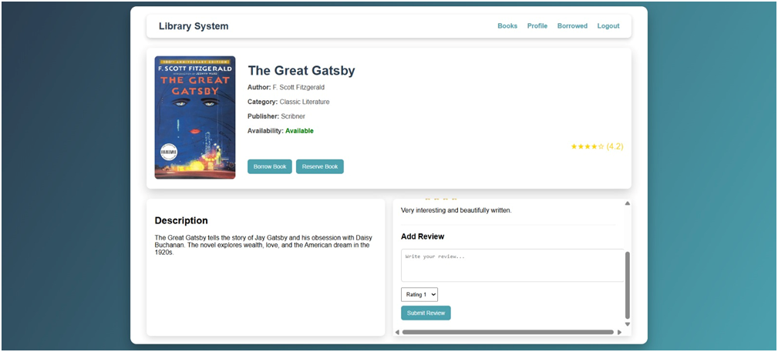
The Administrator control panel: This provides administrators with full manageent capabilities, including adding or removing users, creating, editing, or deleting resources, and managing lending options.

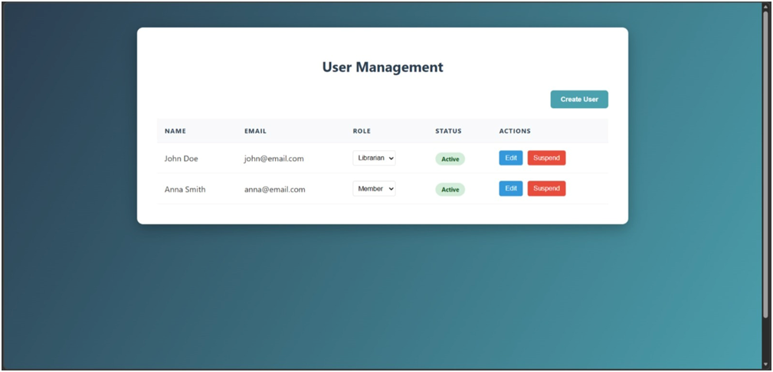
Notifications Interface: This interface serves as the communication hub for users, displaying critical alerts such as the availability of a previously reserved book, confirmation of new reservations, and return deadline reminders. Users can view the details of each notification, mark messages as read, and filter alerts based on urgency or date. The interface is specifically designed to prevent late fees by proactively informing members about the status of their loans.
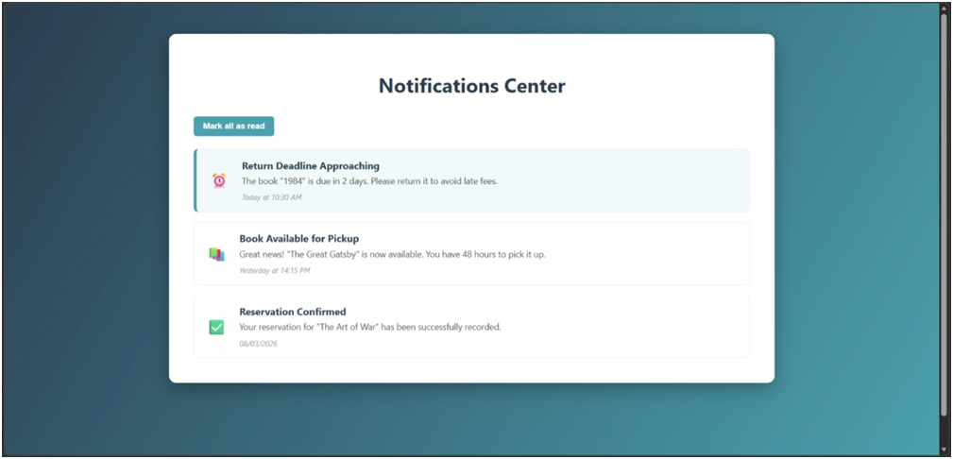
User Dashboard: This is the personalized landing page for each role (Administrator, Librarian, or Member), providing a high-level overview of recent activity. For library members, the dashboard includes quick statistics on currently borrowed books, upcoming deadlines, and recommendations based on reading history. For administrators, it displays system performance metrics and shortcuts to user management modules.
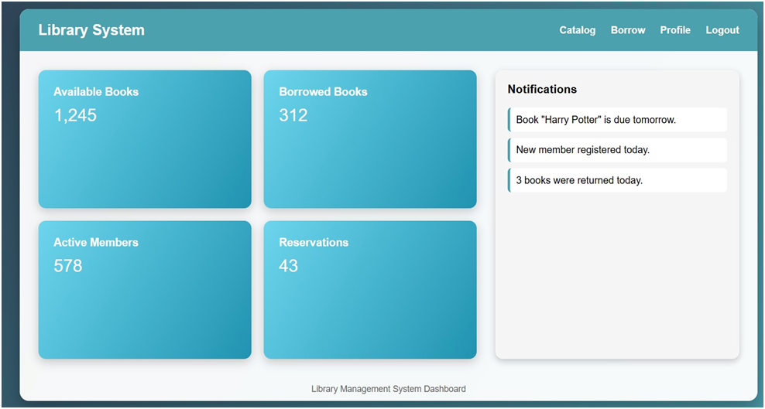
User Profile Page: In this section, users can view and update their personal information, such as name, email address, and contact details. Members can consult their full history of past loans, check their membership status, and change their access password to maintain account security. Any modification made to the profile is recorded in the system's security logs.
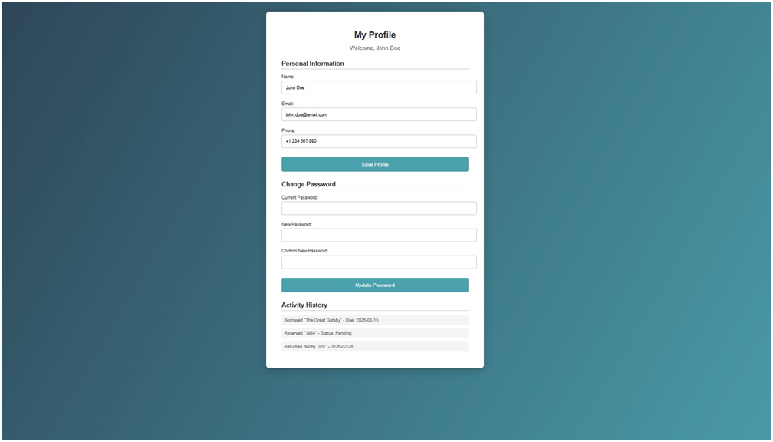
Book Management Interface-Librarian: This interface provides librarians with a centralized platform to manage the library's collection, featuring integrated controls for adding, editing, and deleting book records. Each book is presented within a clean, white informational card that displays the book's cover art, title, author, and specific genre (e.g., Classic Literature or Fantasy), along with dedicated buttons for real-time data modification. The layout ensures system-wide visual consistency by utilizing white containers set against the signature teal gradient background, supported by a top navigation bar for seamless switching between the Dashboard, Book Catalog, and Category Management.
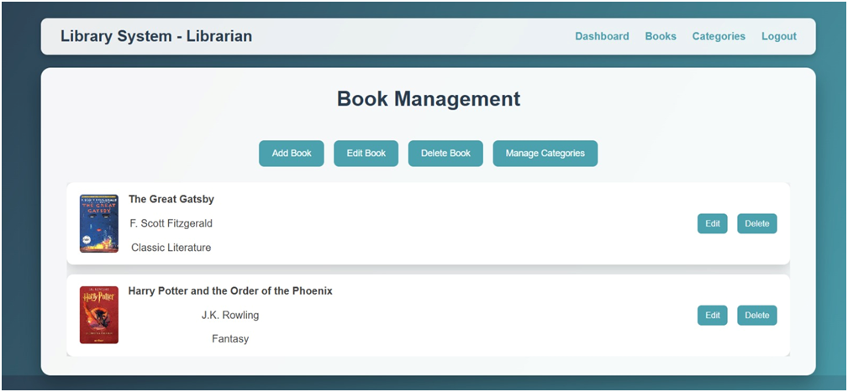

l major system components, including login/logout, user management, book management, search, reporting, stock verification, and category management. Each interface will follow a consistent layout and style guide, with standardized buttons, menus, forms, and error messages to ensure usability and clarity.
Navigation will be intuitive, with help functions and keyboard shortcuts supported where appropriate. Administrators will have full access to create, update, and manage data, while regular users will have restricted access according to their roles. All screens will be designed to support tabular data display, search filters, and report generation, ensuring that all modules are integrated into a coherent and user-friendly interface.
All interfaces will be customizable by administrators while maintaining a consistent standard template, ensuring that the system is intuitive, secure, and user-friendly. Detailed screen layouts, GUI standards, and sample images will be documented separately in the user interface specification.

Hardware Interfaces
Not applicable.

Software Interfaces
The Library Management System will run on Windows, and will interact with a PostgreSQL database to store and manage all data related to books, members, borrowing records, and reports.
The system will use standard web technologies (HTML, CSS, JavaScript, Bootstrap) for the user interface and Java with Spring Boot for the backend to handle business logic, including borrowing, reservations, report generation, and user authentication.
All communication will occur over standard protocols (HTTP/HTTPS for the web interface and SQL for database interactions). Shared data will be managed through the database to ensure consistency, security, and transactional integrity.

Communications Interfaces
The system will facilitate the exchange of information between users and the server through standardized communication protocols, ensuring a secure and efficient data flow. Communication requirements will be structured as follows:
- Network Protocols: The application will be accessed via the HTTP/HTTPS protocol, ensuring the interface will display correctly in the web browsers used by library members.
- Server Communication: The application will use secure connections to query the centralized database, guaranteeing that loan and return transactions will be processed quickly and without data loss.
- Database Synchronization: The application will maintain a constant connection with the database server so that any updates to the book inventory or user status will be visible instantly on all internet-connected computers.
- Network Standards: The system will comply with network standards necessary for remote access, ensuring that the interface will remain compatible with different online browsing environments.
- Notifications: via email.

System Features

LOGIN
4.1.1 Description and Priority
This feature allows registered users(members,librarian and administrators) to
log into the system using valid authentication credentials (username and password).
Authentication is required to access the system's functionalities according to the user's assigned role (administrator, librarian, member).

Priority: High - Essential for system security and access control.

4.1.2 Stimulus/Response Sequences
- The user enters their username and password into designated fields and presses the login button.
- After this, the system verifies the credentials and authorizes access based on the user's role.
- If authentication is successful, the user is redirected to the corresponding home page.
- If authentication fails, the system displays an error message.
4.1.3 Functional Requirements
REQ-1:The system shall authenticate users using a valid username and password combination. Otherwise, authentication fails.
REQ-2:If authentication fails, the system displays an error message.
REQ-3: If authentication succeeds, the system assigns the user role(Member,Librarian,Administrator)
REQ-4: The system shall record every login attempt (successful or unsuccessful) in the system log for security and auditing purposes.
REQ-5: The system must allow password reset.

MEMBER PROFILE
4.2.1 Description and Priority
This feature allows library members to view and manage their personal account information, including contact details and membership status.
Priority: High – Essential for members to manage their library account.
4.2.2 Stimulus/Response Sequences
- The member selects the "Profile" option from the navigation menu.
- The system displays personal details and membership information.
- The member logs in for the first time → The system displays a data processing consent form (if applicable).
- The member accepts the terms → The system allows access to the profile page.
- The member edits personal details (phone number, address).
- The member saves the changes.
4.2.3 Functional Requirements
REQ-6: On first login, the system shall display a personal data processing consent form and request approval.
REQ-7: If the member accepts the terms, the system shall allow access to the profile page.
REQ-8: If the profile page is opened, the system shall display personal information (name, email, phone number, address) and membership status.
REQ-9: If the member edits personal details, the system shall validate and update the information in the database.
REQ-10: If a profile modification occurs, the system shall log the change for tracking.

BOOKS VIEW
4.3.1 Description and Priority

This feature allows registered users to search and filter books available in the library. Users can view detailed information about each book and check availability.
Priority: High – Essential for members to find and access desired books.
4.3.2 Stimulus/Response Sequences
- The user enters the title, author, or keywords in a search field.
- The system returns a list of books matching the search criteria.
- The user clicks on a book from the results to view detailed information.
- The user can access the details of each book.
4.3.3 Functional Requirements
REQ-11:If a user searches for a book, the system shall allow filtering by multiple criteria, including title, author, category, or keywords.
REQ-12: If a user views search results,t he system will display the available stock for each branch.
REQ-13: If a user selects a book from the search results, the system shall display detailed information about that book.
REQ-14: If the user performs a search, the system will display relevant results.

LOAN AND RESERVATION MANAGEMENT
4.4.1 Description and Priority
This feature allows registered and authenticated user to borrow and reserve an available book from the library system. The system records and updates the status of the selected book accordingly.
Priority: High – Represents a fundamental operational component of the system.
4.4.2 Stimulus/Response Sequences
- The user logs into the system.
- The system displays the user’s home page.
- The user selects a specific book.
- The system displays detailed information about the selected book, including availability status.
- The user confirms the borrowing request. →The system verifies that: the book is available and that the user has not exceeded the borrowing limit.
- If all conditions are satisfied, the system records the borrowing transaction and assigns a due date. →The system confirms that the book has been successfully issued.
- When the loan period expires, the user receives a notification for the return.
- Users can reserve books that are not currently available for borrowing.
4.4.3 Functional Requirements
REQ-15: If a member selects an available book and confirms the borrowing request, the system will issue the book and assign it to that member.
REQ-16: If a member attempts to borrow a book, the system shall verify that the book is currently available.
REQ-17: If a member tries to borrow a book, the system ensures that the member has not exceeded the maximum borrowing limit.
REQ-18: When a borrowing transaction is successfully completed, the system records the Member ID, Book ID, borrow date, and due date in the database.
REQ-19: Users can reserve unavailable books for later borrowing.

4.5 USER MANAGEMENT
4.5.1 Description and Priority
This feature allows administrators to take full control of user accounts in the system.
Priority: High – Essential for keeping the system secure and organized.

4.5.2 Stimulus/Response Sequences
- The administrator logs into the system and navigates to the user management section.
- The administrator can choose to add a new user, edit, or delete an account.
- The system validates the information and confirms the action.
- If an account is inactive, the administrator can delete it.

4.5.3 Functional Requirements
REQ-20: If an administrator wants to create or edit a user, the system will let them add or update member accounts with all necessary details.
REQ-21: Administrators can ban or suspend user accounts if users violate library rules or fail to return borrowed books on time.
REQ-22: Administrators can remove a ban and reactivate a user account if the issue has been resolved.
REQ-23: The system shall prevent banned users from borrowing books.
REQ-24: Administrators can delete accounts of inactive users.
REQ-25: The system shall display the reason for the ban in the user account details.
REQ-26: The system shall record all banning and unbanning actions in the security logs.

4.6 NOTIFICATIONS
4.6.1 Description and Priority
This feature allows users to receive notifications about reservations, loans, due dates, returnes and overdue items.
Priority: High – Essential for keeping users informed and improves the library experience.
4.6.2 Stimulus/Response Sequences
- The system checks for reservations, loans, upcoming due dates, overdue items and returnes and sends notifications to the users.
- Users can update their notification preferences.
4.6.3 Functional Requirements
REQ-27: If a loan is approaching its due date, the system will notify the users.
REQ-28: If a user wants, the system will let them personalize their notification settings
REQ-29: Users are notified about new books added to the library.
REQ-30: Librarians are alerted about overdue returns.
REQ-31: The system sends notifications via email.

4.7 LIBRARIAN PROFILE
4.7.1 Description and Priority
This feature allows librarians to view and manage their personal accounts , assigned responsibilities and information.
Priority: High – Essential for librarians to manage their accounts and perform duties effectively.
4.7.2 Stimulus/Response Sequences
- The librarian selects the "Profile" option from the navigation menu.
- The system displays personal and professional details, including role and access permissions.
- The librarian edits personal details (phone number, email, address) or updates professional information (assigned sections, responsibilities).
- The librarian saves the changes.
- The system confirms that the updates have been applied successfully.
4.7.3 Functional Requirements
REQ-32: If a librarian accesses their profile, the system displays their dedicated profile page.
REQ-33: If the profile page is opened, the system shall display personal information (name, email, phone number, address) and professional details (role, access level, assigned responsabilities)
REQ-34: If the librarian edits profile details, the system shall validate the input and update the information in the database.
REQ-35: If a profile modification occurs, the system shall log the changes for auditing and tracking purposes.

4.8 LIBRARY MANAGEMENT
4.8.1 Description and Priority
This feature allows librarians to manage the library catalog, including adding new books, editing existing book details, and removing books that are no longer available.
Priority: High – Essential functionality for maintaining the library catalog.
4.8.2 Stimulus/Response Sequences
- The system displays a list of all books in the catalog, including title, authors, publisher, category, and availability status.
- The librarian can choose to: Add a new book → the system displays a form to enter book details. Edit an existing book → the system displays the current details for modification. Delete a book → the system asks for confirmation before removal.
- The librarian fills in or modifies the book information and submits the form.
- The system validates the input, updates the catalog, and confirms the action.
4.8.3 Functional Requirements
REQ-36: Librarians can add and update information about books.
REQ-37: If a librarian adds a new book, the system shall validate the input and add the book to the catalog with all relevant details (title, authors, publisher, category and availability).
REQ-38: If a librarian edits an existing book, the system shall allow modification of any
book detail and update the catalog accordingly.
REQ-39: If a librarian deletes a book, the system will remove it after confirmation
REQ-40: If the catalog is updated, the system will refresh availability and track stats
REQ-41: The system will highlight damaged or lost books.
REQ-42: Librarians can set rules for special loans.

4.9 LIBRARIAN MANAGEMENT
4.9.1 Description and Priority
This feature allows administrators to view, add, and remove librarians in the system. It ensures that library staff accounts are properly managed, and that only authorized ones can perform librarian tasks.
Priority: High – Essential for managing library staff and controlling access.
4.9.2 Stimulus/Response Sequences
- The administrator selects the "Librarians" section from the main dashboard.
- The system displays a list of all current librarians, including their names, roles, and contact information.
- The administrator can add a new librarian by filling in required details (name, email, role, password).
- If the administrator edits an existing librarian, the system shall allow modification of any detail (name, role, contact info, access level) and update the database.
- The administrator can remove a librarian if they have no longer require access.
- The system confirms all additions and deletions and updates the database accordingly.
4.9.3 Functional Requirements
REQ-43: If the administrator selects "Librarians," the system shall display a complete list of all librarians with relevant details
REQ-44: If the administrator selects "Add Librarian," the system shall allow them to input the new librarian’s details and create the account.
REQ-45: If the administrator removes a librarian, the system shall delete the
librarian’s account from the database and log the action.

4.10 REVIEWS AND RATINGS
4.10.1 Description and Priority
This feature allows members to rate and write reviews for books available in the library. The goal is to provide feedback to other users and encourage community engagement, creating a more interactive library experience.
Priority: Medium – Enhances user experience and provides useful insights about book popularity and quality.
4.10.2 Stimulus/Response Sequences
- The member selects a book from the catalog.
- The system displays the book’s detailed page, including existing reviews and ratings.
- The member chooses to add a review or a rating.
- The system validates the review content and records the rating (1 to 5 stars).
- The review and rating are saved in the database and immediately visible to other users.
- Users can view reviews and ratings from other members to make informed decisions.
- 4.10.3 Functional Requirements
- REQ-46: The system shall allow members to add a review for any available book.
- REQ-47: The system shall allow members to give a numeric rating (1–5 stars) to each book.
- REQ-48: Reviews and ratings shall be stored in the database associated with the member ID and the book ID.
- REQ-49: Published reviews shall be visible to all users who access the book’s page.
- REQ-50: Members shall be able to delete their own reviews.
- REQ-51: The system shall calculate and display the average rating of a book based on all received ratings.

5.0 SECURITY LOGS
5.0.1 Description and Priority
This feature allows administrators to monitor and all system activities. It records user actions such as login attempts, profile edits, book borrowings, reservations and returns, catalog modifications, and account management events.
Priority: High – Essential for system security, integrity, and tracking user activities..
5.0.2 Stimulus/Response Sequences
- The system displays a list of logged activities with details such as user ID, action type,and affected resource.
- The administrator can filter logs by user, date range, or action type.
- The administrator can export logs for reporting purposes.
5.0.3 Functional Requirements
REQ-52: If the system records an action (login, edit, delete, borrow), the system shall log the user ID, action type, affected resource, date, and time.
REQ-53: If the administrator applies filters, the system shall update the displayed logs to match the selected criteria.
REQ-54: The system shall protect logs from anyone trying to delete them.

5.1 REPORT GENERATION
5.1.1 Description and Priority
This feature allows administrators to generate detailed reports on the library's activity.
Priority: Medium – Useful for statistical analysis and administrative monitoring.
5.1.2 Stimulus/Response Sequences
- The administrator selects the desired type of report.
- The system processes the request and generates the corresponding report.
- The report can be exported as a downloadable document.
5.1.3 Functional Requirements
REQ-55: The system allows reports to be exported in PDF format.
REQ-56: Detailed reports about overdue returns can be generated.
REQ-57: Administrators can filter reports by categories such as books, users, and loans.
REQ-58: Reports highlight the most frequently borrowed books.
REQ-59: The system will generate monthly reports on the library's activity.

5. Other Nonfunctional Requirements

Performance Requirements
The proposed system will serve as the primary platform for library management, interacting simultaneously with administrative staff and members (readers). For this reason, the application’s performance must meet the following criteria:
- Speed and Accuracy: Database query response times should be minimal, ensuring fast and precise processing of transactions such as book loans and returns.
- Error Handling: The application must handle both anticipated and unexpected errors, including built-in testing mechanisms to quickly detect invalid authentication attempts.
- Storage Capacity: The system must be able to manage large volumes of data, allowing the registration of a high number of books and users without performance issues.

Safety Requirements
Not applicable.

Security Requirements
• The system shall ensure data integrity and confidentiality by storing all information in a secure database accessible only through authenticated access.
• The system shall enforce strict access control based on user roles. Administrators shall have full permissions to manage and update the database, while regular members shall only have permission to view information and modify their own personal data.
• The system shall implement secure authentication mechanisms to protect user accounts and prevent unauthorized access.
• User passwords shall be protected against hacking attempts through secure storage and authentication procedures.
• The system shall ensure complete separation between administrator accounts and member accounts to prevent unauthorized access to administrative functions.
• Unauthorized users shall not be able to access the database structure or view other users’ personal information.
• The system shall ensure that members can only edit or delete their own reviews to maintain data integrity and prevent misuse.

Software Quality Attributes
- Usability will be prioritized, with an intuitive interface that will allow users to perform essential tasks quickly and efficiently, while ease of learning will be considered secondary.
- Maintainability. The system’s code is designed to support easy updates and modifications with minimal effort. It adheres to established best practices, including modular design, comprehensive documentation, and consistent coding standards to facilitate long-term maintenance.
- Reliability: The system is designed to operate consistently and correctly under expected conditions. It should handle errors gracefully, prevent data loss, and maintain service availability.
- Consistent Naming Conventions: All variables, functions, and classes use clear, descriptive names that accurately reflect their purpose and functionality. ensuring readability and reducing the risk of confusion.
- Data validation: User inputs must always be validated to ensure security and prevent potential vulnerabilities.
- Extensibility: The software should be designed to accommodate future enhancements or modifications with minimal changes to the existing code, using design patterns such as Open/Closed Principle (OCP).
- Performance optimization: Unnecessary database calls should be avoided, and SQL queries must be optimized to improve application efficiency.
- Avoiding abbreviations: Variable names should be descriptive and avoid abbreviations, except for well-known acronyms such as "ID," to maintain clarity in the code.
- Modularity: Code should be well-structured by separating business logic from the user interface and breaking functionality into reusable modules to enhance maintainability and scalability.
- Relevant and concise comments: Comments should clearly explain the logic of functions, being concise and useful for a quick understanding of the implementation.
- Avoiding redundancy: Code duplication should be minimized by using reusable functions and components, reducing complexity and improving maintainability.

Business Rules
This software product is designed for implementation of a smart library.

Other Requirements
Not available.
Appendix A: Glossary
A.1 Acronyms and abbreviations:

- SRS (Software Requirements Specification): The current document describing the system's functionalities and constraints.
- GUI (Graphical User Interface): The graphical interface through which the user interacts with the application.
- DBMS / SGBD: Database Management System (e.g., PostgreSQL).
- HTTP/HTTPS: Secure communication protocols over the Internet.
- Three-Tier Architecture: Software architecture divided into three layers: Presentation (UI), Logic (application code), and Data (database).
- Log: A file or database table that automatically records user actions for security purposes.
- DB (Database) : A structured collection of data that stores information related to members, librarians and administrator.
- PDF (Portable Document Format): A file format used to present and exchange documents in a way that is independent of software, hardware, or operating systems.
- PostgreSQL : An open-source relational database management system known for its scalability and reliability.

A.2 Specific terms:

- Member: A registered user who can borrow books, write reviews, and manage their personal account.
- Librarian: A user responsible for issuing and receiving books, maintaining records, and managing library operations.
- Delinquent Borrower: A member who has exceeded the book return deadline and has active restrictions.
- Administrator: A user with full access to the system, responsible for managing users, catalog management, and maintaining the application.
- Loan:A record representing a book borrowed by a member, including issue date and due date.
- Reservation – A request made by a member to hold a book that is currently unavailable.
- Catalog – The organized collection of books available in the library, including details like title, author, publisher, and category.
- Overdue – A book that has not been returned by its due date.
- Notification – A message sent to a user to inform them about due dates, reservations, or updates.
- Security Log – A record of all system actions performed by users, including logins, edits, deletions, and borrow/return transactions.
- Review: A textual evaluation submitted by a library member regarding a book.
- Rating: A numeric score (1–5 stars) assigned by a member to a book.
- Branch – A physical location of the library, which may have its own collection and policies.
- Special Loan – A loan with modified rules, such as extended borrowing period or restricted availability.

Appendix B: Analysis Models
Analysis models will be included to better understand the application. The UML models that will be included are use-case, activity diagram, class diagram, relational model for database.
Appendix C: To Be Determined List
Not available.

